## Instructions for compiling ISOmodel using Visual Studio 2017 community edition

Download FS 2017 community addition and begin install:

Select Desktop development with C++ and use default settings

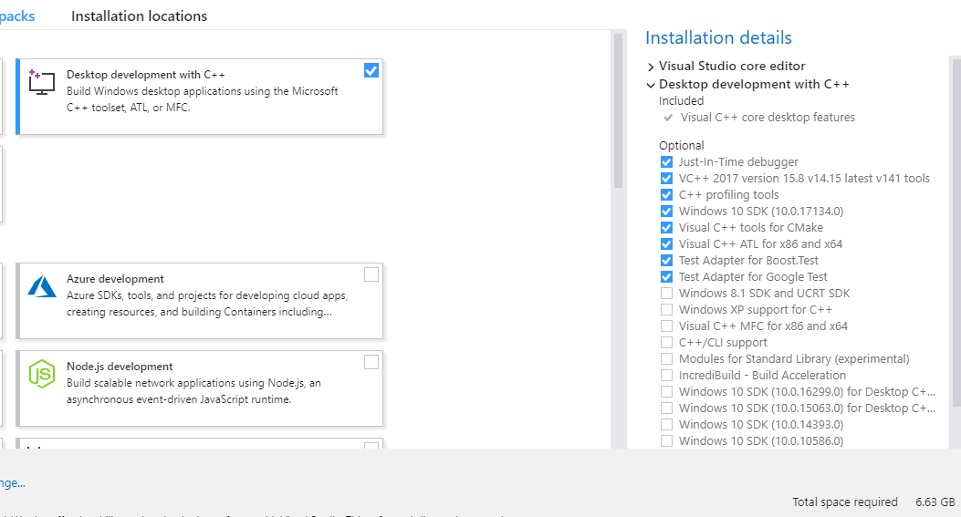

## Install CMake 3.12.3

<https://cmake.org/files/v3.12/cmake-3.12.3-win64-x64.msi>

Installed using option “add Cmake path to all users”

## Install Boost 1.68 prebuilt binaries for msvc 14.1-64

<https://sourceforge.net/projects/boost/files/boost-binaries/1.68.0/boost_1_68_0-msvc-14.1-64.exe/download>

Installed to C:\local\boost_1_68_0

## Install Google Test 1.8.1

<https://github.com/google/googletest/archive/release-1.8.1.zip>

Installed to C:\local\googletest_1_8_1 (only the googletest directory)

## Compiling Google Test using Visual Studio IDE

Load the gtest-md.sln from the google test msvc directory and let it convert (this is the static lib)

(e.g c:\local\googletest_1_8_1\msvc\2010\gtest-md.sln)

Set the build settings to Release and X64



### Build the full gtest solution:

I did a right click on Solution ‘gtest’ (4 projects) and selected “Build Solution”

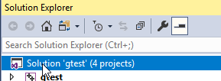

This completed with some warnings but no failures on my machine

You probably want to move gtest.lib and gtest-main.lib to \lib for easier finding by cmake

i.e. move

c:\local\googletest_1_8_1\msvc\2010\gtest-md\x64-Release\*.lib

to

c:\local\googletest_1_8_1\lib

## Compiling isomodel using Visual Studio IDE

First we need to create the .sln files

Go to isomodel directory root (e.g.e c:\git\isomodel\isomodel\) and make a binary directory

cd C:\git\idomodel\isomodel\bin

mkdir bin

cd bin

cmake ../src -G "Visual Studio 15 2017 Win64" -DBoost_LIBRARY_DIR="C:/local/boost_1_68_0/lib64-msvc-14.1" -DBoost_INCLUDE_DIR="C:/local/boost_1_68_0" -DGTEST_ROOT="c:/local/googletest_1_8_1"

This worked without errors to create the project files for visual studio.

Load isomodel_project.sln into Visual Studio

Change build to Release, x64 and build the entire project